18. Plant Biology I: Anatomy and Growth *(RHM: Chapter 29, 33)*

______________________________________________________________________________

I. Plant Characteristics

A. Cellular Characteristics

B. Organismal Characteristics

II. Basic Angiosperm Morphology & Anatomy *(671-672, 786-789)*

A. General Body Plan

B. Angiosperm Diversity: Monocots versus Eudicots

C. Root System

1. Taproots

2. Fibrous roots

D. Shoot System

1. Stems

2. Leaves

3. Flowers

III. Plant Cells, Tissue Types, and Tissue Systems *(789-796)*

A. Cell Growth

1. Cellulose and cell walls

2. Elongation

B. Plant Cell Types and Tissue Types

1. Parenchyma

2. Collenchyma

3. Sclerenchyma

C. Combining Cells and Tissues into Tissue Systems

1. Tissue systems: ground, epidermal, vascular

2. Arrangement of tissue systems in roots, stems, leaves

IV. Plant Growth *(796-808)*

A. Introduction

B. Primary Growth

1. Definition

2. In roots

3. In shoots

C. Secondary Growth in Eudicots

1. Definition

2. In shoots

3. In roots

18-1

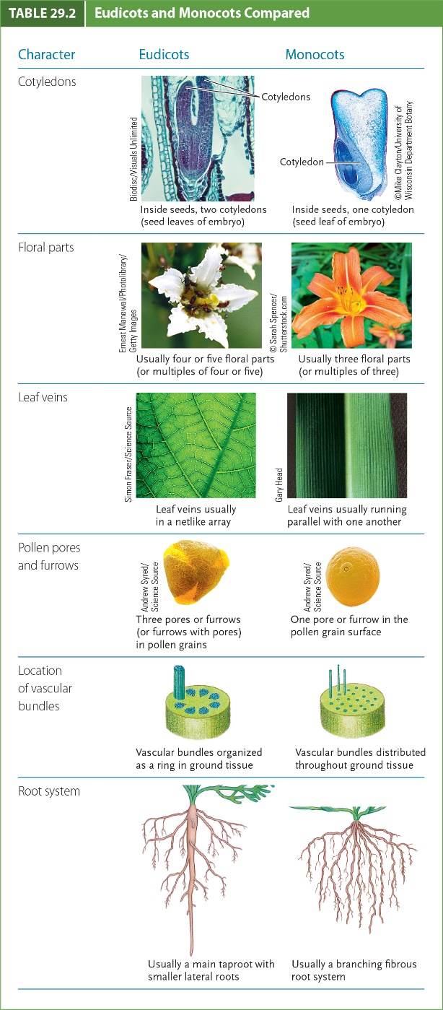

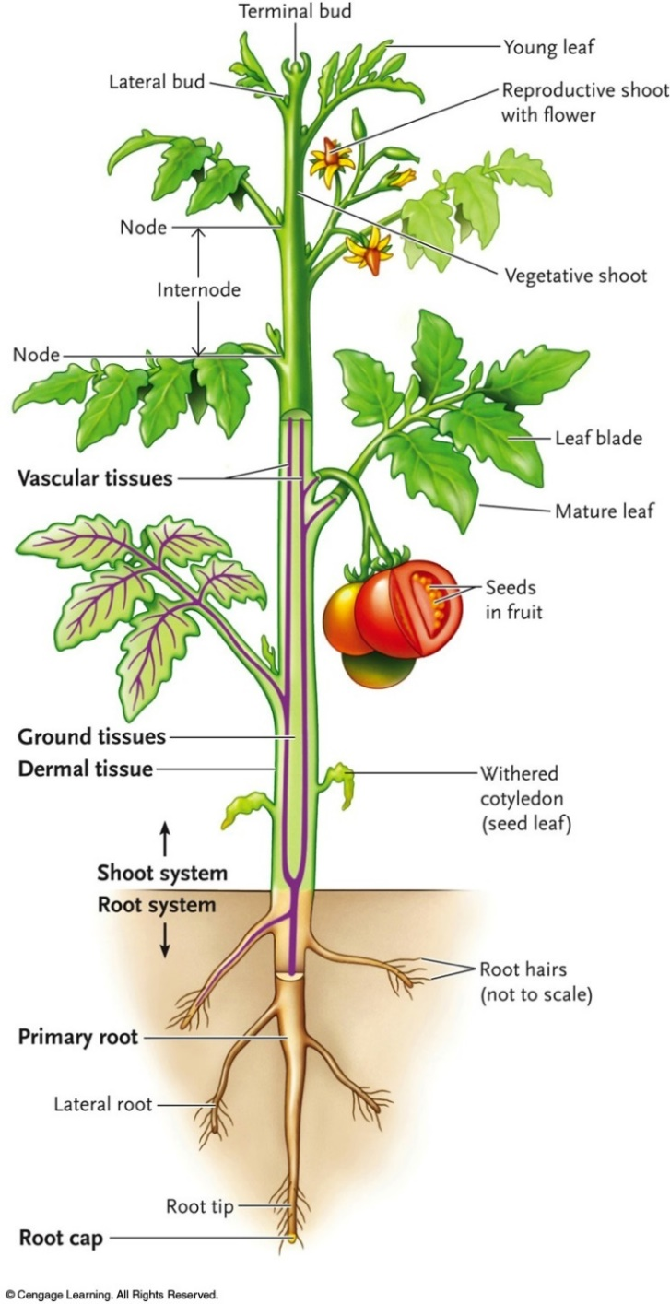

18-2

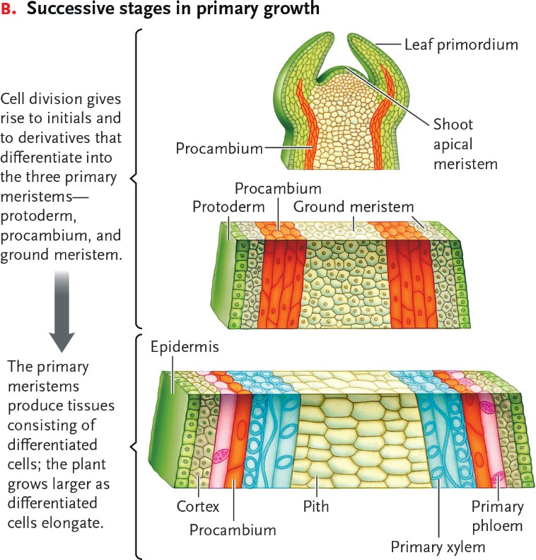

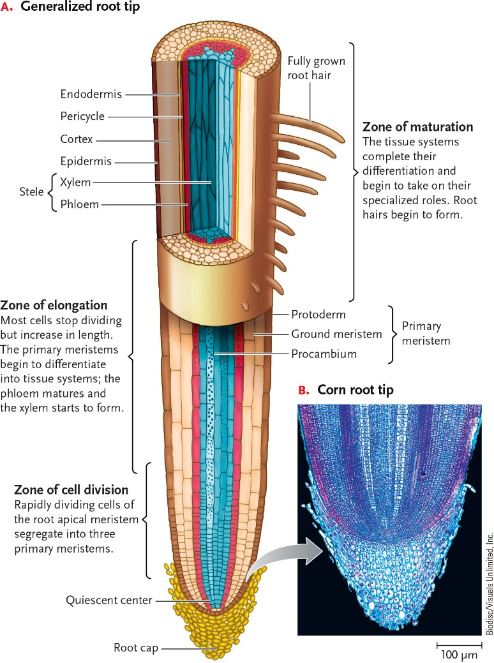

18-3

